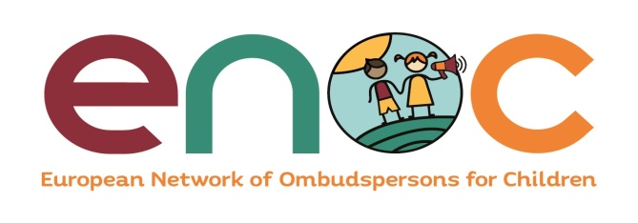

Third Edition 2021

# In this issue:

Newsletter

June – July 2021

ENOC News and Announcements p. 1-2

Update on European and International Activities in the children’s rights field p. 2-3

Update on ENOC members’ activities

p. 3

Publications p. 2

* **ENOC News and Announcements**

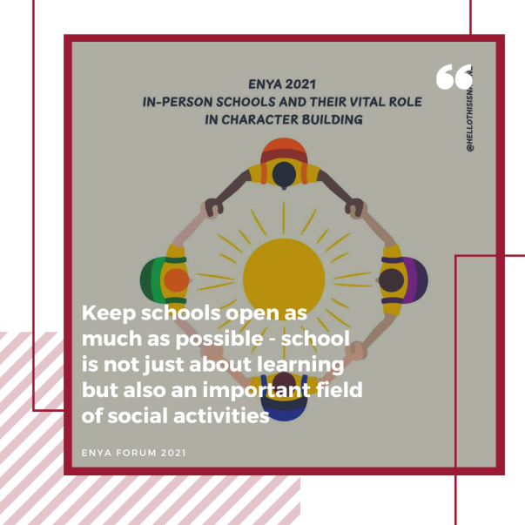

**ENYA Forum “Let’s Talk Young, Let’s Talk about the impact of COVID-19 on children’s rights”**

The **ENYA 2021 Forum “Let’s talk young, let’s talk about the impact of COVID-19 on children’s rights”** took place online on **1-2 July 2021**. Young people from 17 countries/regions (Albania, Andalusia/Spain, Basque country/Spain, Bulgaria, Catalonia/Spain, France, Greece, Iceland, Italy, Malta, Montenegro, Norway, Northern Ireland/UK, Slovakia, Scotland/UK, Wales/UK, Ukraine) participated in the ENYA child participation project this year. This project aims at giving the opportunity to children and young people to express their views on ENOC’s annual theme “COVID-19: learning for the future”, and share their experiences of the impact of COVID-19 states’ measures.

**Upcoming Events**

**Save the dates!**

**27-28 September 2021:**

**ENOC 25th Annual Conference “COVID-19: learning for the future” – *Hybrid event (Athens, Greece and online)***

**29 September 2021:**

**ENOC 25th General Assembly meeting – *Hybrid event (Athens, Greece and online)***

At the final stage of countries’ activities, two elected young representatives per country/region, accompanied by the ENYA Coordinators, participated in the ENYA Online Forum hosted by the Commissioner for Children Malta. The ENOC Secretariat and several Ombudspersons and Commissioners for Children joined the event. Country/region teams presented the outcomes of their domestic activities, and discussed various issues affected by the COVID-19 pandemic: education, health, poverty, violence and abuse, participation, family, digital environment, information, and leisure and play. Young advisors discussed and agreed on common recommendations on these issues. The ENYA Forum was also the opportunity for young people to participate in creative and fun online activities: icebreakers, Kahoot quiz, escape game, virtual tour of Malta’s Hypogeum, music workshop, etc.

The ENYA recommendations will be presented at the ENOC 25th Annual Conference on 27-28 September 2021 and reflected in the ENOC Position Statement on “COVID-19: learning for the future”. Learn more [here](http://enoc.eu/?event=enya-forum-lets-talk-young-lets-talk-about-the-impact-of-covid-19-on-childrens-rights).

**ENOC Online Seminars: 1) COVID-19: learning for the future 2) ENOC Standards & Values**

As part of its 2021 work plan, ENOC organised a first round of discussions on the issue of **"COVID-19: learning for the future"** on the occasion of a working seminar that took place online on **1 June 2021**.

This Seminar was the opportunity for more than 50 ENOC members representatives to share experience, and to discuss and prepare the basis of the future ENOC Statement on the annual theme. The event started with a presentation by **George Nikolaidis**, Director of the Department of Mental Health and Social Welfare at the Institute for Child Health in Athens, on the impact of the pandemic and related measures on children’s mental health and on domestic violence. Then, the two experts supporting the ENOC’s work on “COVID-19: learning for the future”, **Pr. Simon Hoffman and Rhian Croke**, presented the key findings of the survey mapping the impact of emergency measures introduced in response to the COVID-19 pandemic on children’s rights in ENOC member states. This was followed by an update on the ENYA project and initial feedback from young people, and by a discussion on the first draft of the ENOC Position Statement and how to better uphold children’s rights in times of pandemic, global crisis or public health emergency.

This working seminar was organised with the support of the Deputy Ombudsperson for Children in Greece, who is leading the work on “COVID-19: learning for the future”.

1

On the same occasion, ENOC held a capacity building session on the **ENOC Standards and Values** on **4 July 2021**. A working group was established at ENOC’s 2020 Annual General Assembly meeting to agree on the values and standards that should be upheld by ENOC members at all times along with a process for addressing situations where consensus cannot be reached. This online session was the occasion to discuss the first draft of **ENOC Standards and Values** prepared by the Working Group led by the Ombudsman for Children Ireland. Find more information [here](mailto:http://enoc.eu/?event=enoc-2021-online-seminar).

* **Update on European and International activities in the Children’s Rights field**

**Presentation of ENOC’s work on CRIA at the JURI workshop on Mainstreaming Children’s Rights in the EU legislation**

On 26 May 2021, the Policy Department for Citizens Rights and Constitutional Affairs of the European Parliament organised a workshop on "Mainstreaming children's rights in the EU legislation under the Better Regulation Agenda" for the JURI Committee, in the presence of the EP Coordinator for Children's Rights, **Ms. Ewa Kopacz**. The aim of the workshop was to explore the possibility to embed in the existing rules and guidelines of impact assessment for new and reviewed legislative proposals, a "child rights" test. As all EU legislation may influence directly or indirectly the lives and wellbeing of Europe’s youngest citizens, such a tool could help lawmakers to identify and ensure measures that will promote and protect the rights of the child as guaranteed by EU and International law. The workshop also examined how children's right to participate in the EU decision-making process can be put in practice. **Bruce Adamson, ENOC Chair**, participated in this event and presented ENOC’s work in the field of child rights impact assessment (CRIA). Experts from the European Commission were present as well to outline the current elements of the better regulation agenda that include child rights perspective in EU legislation. Find more information [here](https://www.europarl.europa.eu/committees/en/workshop-on-mainstreaming-children-s-rig/product-details/20210517WKS03581).

**Plenary session of the CDENF dedicated to the review of the Draft Strategy for the Rights of the Child, 14-15 June 2021**

The Steering Committee for the Rights of the Child (CDENF) held a plenary session dedicated to the review of the Draft Strategy for the Rights of the Child (2022-2027) in an online format on 14 and 15 June 2021 with Ms Maria-Andriani Kostopoulou (Greece) in the Chair. The Steering Committee pursued the examination and revision of the draft Strategy during this session. Read more [here](https://www.coe.int/en/web/children/cdenf#{%2262825882%22:[5]}).

**Adoption of the European Child Guarantee, 14 June 2021**

The Employment, Social Policy, Health and Consumer Affairs Council (EPSCO) adopted the Commission proposal on establishing a European Child Guarantee on 14 June 2021. The objective of the European Child Guarantee is to prevent and combat social exclusion by guaranteeing the access of children in need, at risk of poverty or social exclusion, to a set of key services: early childhood education and care, education, healthcare, nutrition, housing. Learn more [here](https://ec.europa.eu/social/main.jsp?langId=en&catId=89&newsId=10024&furtherNews=yes).

**New Human Rights Comment by the Council of Europe Commissioner for Human Rights “Boosting child and youth participation – from voice to choice”**

The Council of Europe Commissioner for Human Rights, **Dunja Mijatović** released a new Human Rights Comment on child participation called “Boosting child and youth participation – from voice to choice”. This Comment stresses that children’s concerns were neglected

# Publications

**Call for participants: Compasito training course for Human Rights Education with Children**

The Council of Europe Youth Department in close cooperation with the Children’s Rights Division is launching a call for trainers, educators, activists or volunteers who would be interested in participating in the Compasito training course for Human rights education with Children, to take place at the European Youth Centre Budapest on 17-24 October 2021. By bringing together young educators, activists, and multipliers, the Compasito training course aims to motivate and develop the capacity to implement training or education activities on human rights education. It is targeted towards those who work in the field of human rights education with children (directly or indirectly) and who are looking for practical tools with which to discuss values and social issues with children. The training course will be based on the revised Compasito. Compasito seeks to develop in children the knowledge, skills, values and attitudes they need to participate in their society, knowing and protecting their rights and the rights of others. In this way, children can actively contribute to building a culture of human rights. Deadline to apply: 7 September 2021. You can find more information [here](https://www.coe.int/en/web/human-rights-education-youth/-/call-for-participants-compasito-training-course-for-human-rights-education-with-children).

**New mobile app to improve access to support and services for young people in out-of-home care**

The Viewpoint organisation and the Advocate for Children in Care in Western Australia have developed the myView app, a new mobile app to improve access to support and services for young people in out-of-home care. The myView app has been developed to provide a simple tool that empowers young people in out-of-home care with access to direct information and a resource that ensures that their voices are heard. It has been developed in consultation with young adults who have been in care and provides access to important information, emergency help and direct contact with case workers, advocacy and complaints services. The myView app provides access to self-assessment questionnaires for completion by children and young people. The myView app has been developed so that it can be configured uniquely for any service. Learn more [here](https://www.vpthub.com/).

2

neglected in the wake of the pandemic in many Council of Europe member states. The current opportunity of “building back better” should be seized to give new impetus to Article 12 CRC. Since today’s children will bear the consequences of today’s decisions, whether regarding the environment, health policies or economic recovery post-COVID, governments should move away from symbolic approaches to child participation and empower young people to make choices and meaningfully influence their future. Read the Comment [here](https://www.coe.int/en/web/commissioner/-/boosting-child-and-youth-participation-from-voice-to-choice).

The Steering Committee for the Rights of the Child ([CDENF](https://www.coe.int/en/web/children/cdenf)) has launched a series of three webinars to have an exchange on the most urgent challenges related to children’s rights in the context of COVID-19 pandemic. The first edition titled “Overcoming education challenges” was held online on 22 March 2021 with the aim to illustrate the latest activities by UNICEF, OECD and WHO, and have an exchange on good practices amongst the responses provided in the area of education during the current health crises. The webinar brought together CDENF national delegations, participants and observers, as well as international experts and, last but not least, children who had fruitful discussions on a number of important issues, *inter alia*, access to education, digital/home schooling, inclusion, safety and others. Read more [here](https://www.coe.int/en/web/children/-/covid-19-and-children-s-rights-overcoming-education-challenges).

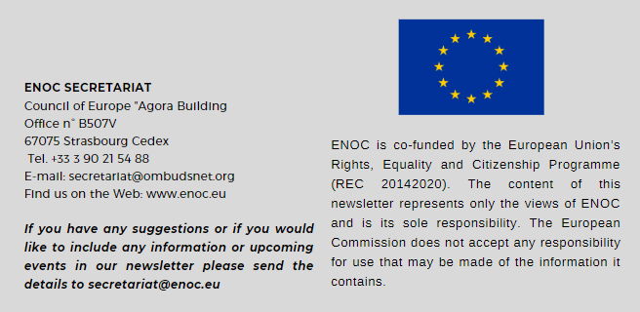

* **Update on ENOC members’ activities**

**New Report by the Ombudsman for the Basque Country: Protection services for unaccompanied minors in Europe**

The Ombudsman for the Basque Country recently released a report called “Protection services for foreign unaccompanied minors in Europe” as part of a common endeavor of the IOI Europe, together with the National Ombudsman of the Netherlands and the Greek Ombudsman who have produced reports on the integration of asylum seekers and refugees, border procedures and return operations. The report is the result of exhaustive research into the practice of European countries and their Ombuds institutions, to which several ENOC members contributed, in relation to the first reception of foreign unaccompanied minors in host countries, to later reception stages and to cross-cutting issues that need to be regarded throughout the stay of foreign unaccompanied minors in host countries. The report provides a comprehensive overview of sound practices in the protection and care of unaccompanied foreign children, and makes sure that these practices are in line with the most relevant international standards. Read the report [here](https://www.nationaleombudsman.nl/system/files/bijlage/Ararteko-unaccompanied-minors.pdf).

**Annual Report of the Protector of Citizens in Serbia for 2020**

The Protector of Citizens of the Republic of Serbia has published its Annual Report for 2020. The reporting year was marked by the pandemic of COVID-19 which affected the lives of all citizens, and saw the intensification of the Protector of Citizens’ work. Despite altered conditions of work and the suspension of reception of citizens in the institution, the Protector of Citizens received 5,056 complaints, which is an increase by approximately 54 percent in comparison to 2019. Considering the effect of the pandemic on children’s rights, a major part of the activities of the Protector of Citizens was aimed at the mitigation of the effect of COVID-19 measures in the area of protection of children’s rights. The number of handled cases has almost doubled compared to 2019, and the number of issued recommendations in the area of children’s rights was increased by almost 50 percent in comparison to the previous year. The Protector of Citizens was assisted by its Youth Advisory Panel composed of children from all parts of Serbia, who highlighted the problems they faced throughout the year. Read the report [here](https://www.theioi.org/ioi-news/current-news/the-protector-of-citizens-publishes-its-annual-report-for-2020).

**Statement of the Catalan Ombudsman on the importance of prevention, detection and address of any forms of racism in schools**

The Catalan Ombudsman published a statement calling for a review of existing educational instruments to prevent, detect and address any form of racism in schools. The Catalan Ombudsman stated that in most cases children affected by racial discrimination, probably out of fear, do not report the situation, nor do they seek the support of adults, which contributes to the difficulty of detecting harassment or discrimination. The Catalan Ombudsman calls, among others, for the establishment of a simple, clear and understandable circuit for children and their families to act against harassment and racial discrimination, and to ensure that any communication of this nature by the child is dealt with confidentially and with the maximum sensitivity and expertise, in order to prevent revictimization of the child. Read the Statement [here](https://www.sindic.cat/en/page.asp?id=53&ui=8047).

3